**Assignment No.2**

**Aim:** Setup a wired LAN using Layer 2 Switch. It includes preparation of cable, testing of cable using line tester, configuration machine using IP addresses, testing using PING utility and demonstrating the PING packets captured traces using Wireshark Packet Analyzer Tool.

**Objectives:**

1. To understand the concept of routers.
2. To learn how to implement the connection between devices using a router.

**1 . Types of Networks**

**1. Local Area Network (LAN)**

* Covers a **small area** (e.g., office, campus, factory).
* Uses **Ethernet cables and switches** for connectivity.
* High-speed communication (**100 Mbps to 10 Gbps**).

**2. Wide Area Network (WAN)**

* Covers a **large geographical area** (e.g., cities, countries).
* Uses **routers, fiber optics, and satellite links**.
* Lower speed than LAN but supports long-distance communication.

**3. Metropolitan Area Network (MAN)**

* Covers a **city or metropolitan region**.
* Uses **fiber optics and microwave links**.
* Faster than WAN, typically **10 Gbps to 100 Gbps**.

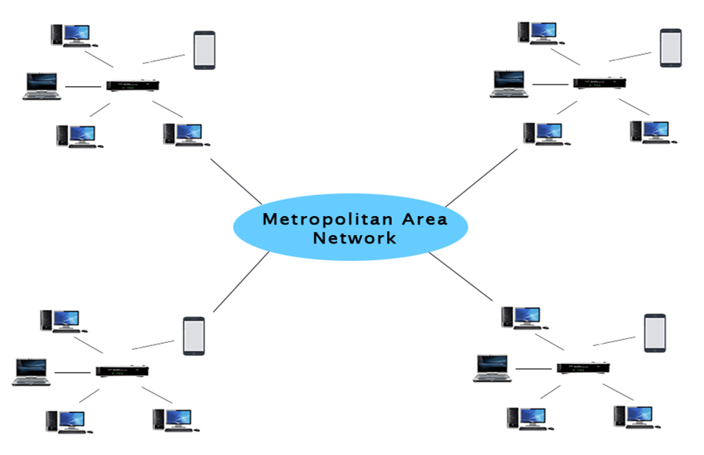

**4. Personal Area Network (PAN)**

* Covers a **very small area** (e.g., workspace, personal devices).
* Uses **Bluetooth, Wi-Fi, Zigbee, NFC**.
* Short-range connectivity (1m - 10m).

**5. Industrial Control Network (ICN)**

* Used in **automation and real-time control systems**.
* Uses **Modbus, PROFIBUS, CAN Bus, Ethernet/IP**.
* Designed for **low-latency and high-reliability** communication.

**6. Storage Area Network (SAN)**

* Dedicated for **data storage and retrieval**.
* Uses **Fibre Channel (FC) or iSCSI**.
* Supports **high-performance computing and cloud storage**.

**7. Enterprise Private Network (EPN)**

* Secure, private network for organizations.
* Uses **VPNs, MPLS, and leased lines**.
* Ensures **centralized IT management and secure communication**.

8**. Campus Area Network (CAN)**

* Covers a **university, corporate campus, or industrial complex**.
* Interconnects multiple **LANs within a limited geographical area**.
* Uses **high-speed Ethernet, fiber optics, and Wi-Fi** for connectivity.
* More secure than MAN but serves a larger area than LAN.

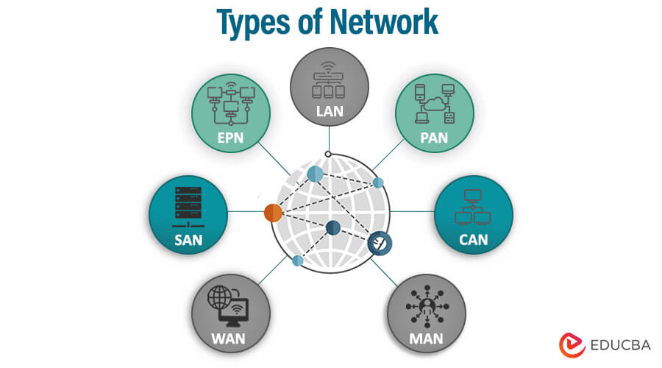

**2. Configurations:**

**1.End Devices(PCs,Laptops,Printers,Smartphones,):**

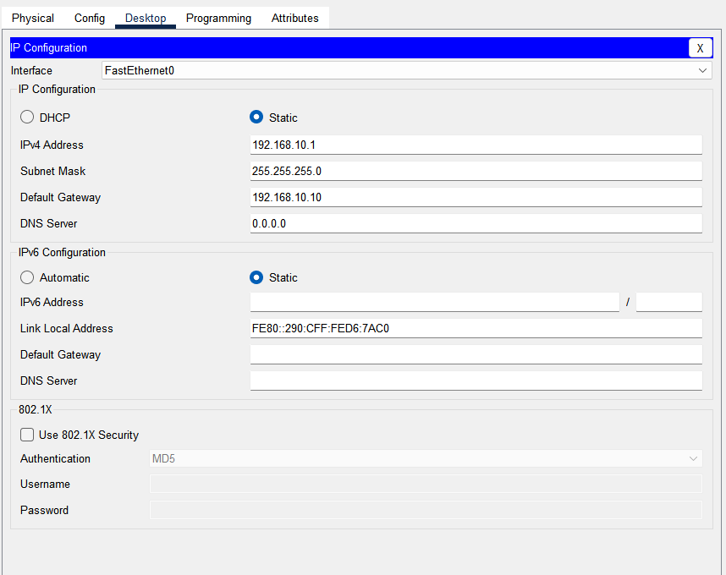

**1. Interface: FastEthernet0**

* The device is connected via a Fast Ethernet interface.

**2. IPv4 Configuration**

* Static IP: The device is manually assigned an IP address instead of obtaining one dynamically via DHCP.
* IPv4 Address: 192.168.10.1 (A private IP address within the 192.168.10.0/24 subnet).
* Subnet Mask: 255.255.255.0 (Indicates a network with a range of 192.168.10.1 to 192.168.10.254).
* Default Gateway: 192.168.10.10 (The router or gateway that connects this network to other networks).
* DNS Server: 0.0.0.0 (Indicates that no DNS server is specified, so name resolution might not work).

**2.Router**

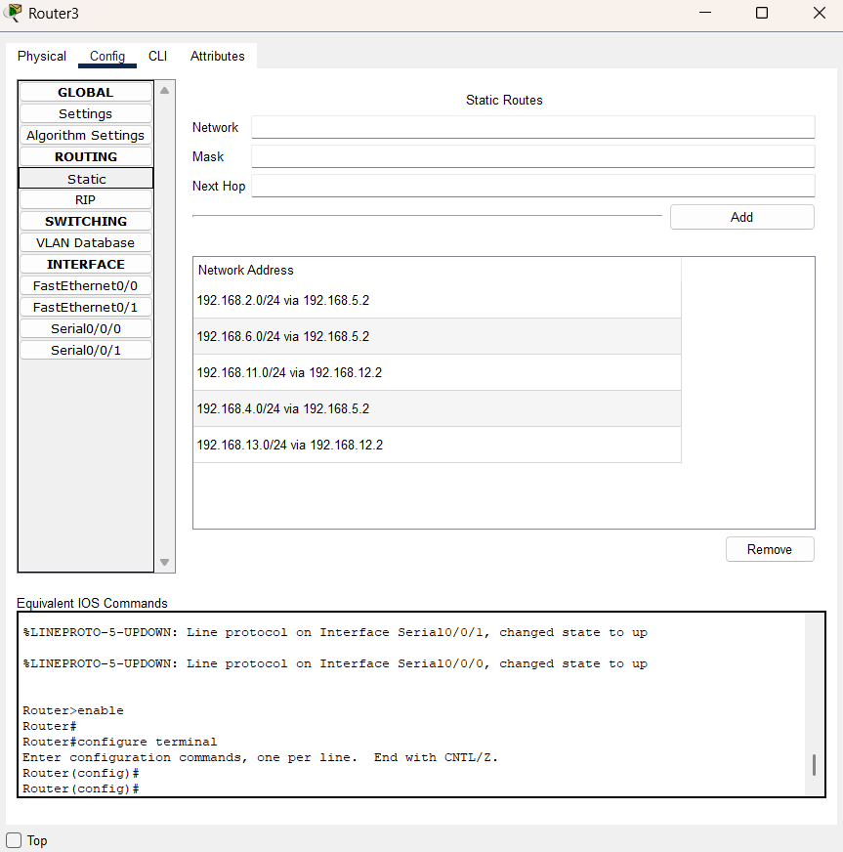

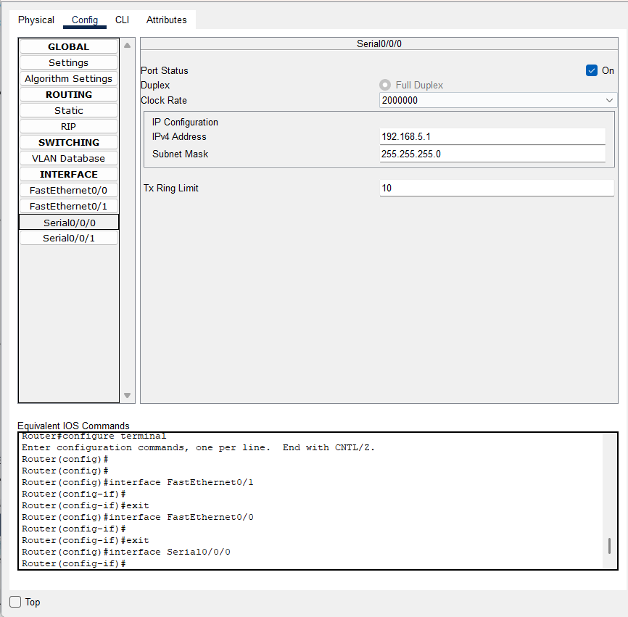

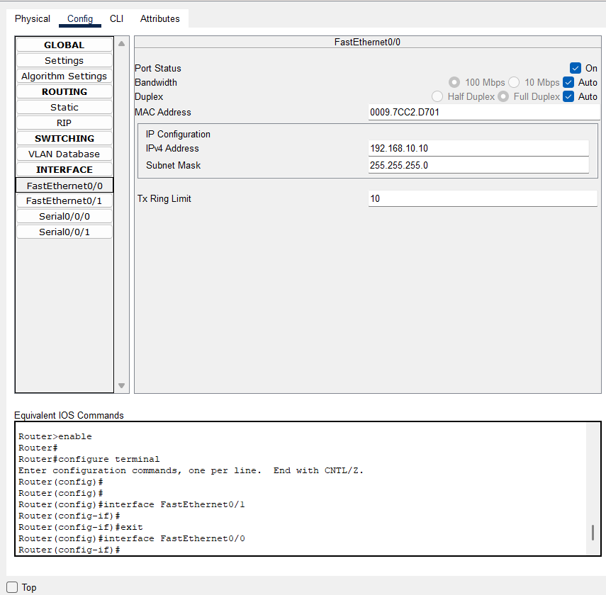

**1. Serial Interface Configuration (Serial0/0/0)**

* Port Status: Enabled (On)
* Duplex: Full Duplex
* Clock Rate: 2000000 (Applicable to DCE end of the serial connection)
* IPv4 Address: 192.168.5.1
* Subnet Mask: 255.255.255.0 (Class A Network)
* Tx Ring Limit: 10 (Determines the transmission queue buffer)

This configuration is typically used for WAN (Wide Area Network) connections between routers.

**2. Fast Ethernet Interface Configuration (FastEthernet0/0)**

* Port Status: Enabled (On)
* Bandwidth: Auto (Negotiates speed)
* Duplex: Auto (Negotiates full/half-duplex mode)
* MAC Address: 0007.ECAD.3E01 (Unique identifier for the interface)
* IPv4 Address: 192.168.10.10
* Subnet Mask: 255.255.255.0 (Class C Network)
* Tx Ring Limit: 10 (Transmission buffer)

**3. Addressing Table/Routing Table:**

**For Router 1:**

|  |  |  |  |
| --- | --- | --- | --- |
| Destination Network | Subnet Mask | Next Hop | Interface |
| 192.168.4.0 | 255.255.255.0 | 192.168.7.2 | Serial1/0 |
| 192.168.6.0 | 255.255.255.0 | 192.168.7.2 | Serial1/0 |
| 192.168.2.0 | 255.255.255.0 | 192.168.7.2 | Serial1/0 |
| 192.168.1.0 | 255.255.255.0 | 192.168.12.1 | Serial0/0 |
| 192.168.10.0 | 255.255.255.0 | 192.168.12.1 | Serial0/0 |

**For Router 2:**

|  |  |  |  |
| --- | --- | --- | --- |
| Destination Network | Subnet Mask | Next Hop | Interface |
| 192.168.10.0 | 255.255.255.0 | 192.168.7.1 | Serial0/0 |
| 192.168.1.0 | 255.255.255.0 | 192.168.7.1 | Serial0/0 |
| 192.168.2.0 | 255.255.255.0 | 192.168.8.1 | Serial1/0 |
| 192.168.6.0 | 255.255.255.0 | 192.168.8.1 | Serial1/0 |
| 192.168.11.0 | 255.255.255.0 | 192.168.7.1 | Serial0/0 |
| 192.168.13.0 | 255.255.255.0 | 192.168.7.1 | Serial0/0 |

**For Router 3**

|  |  |  |  |
| --- | --- | --- | --- |
| Destination Network | Subnet Mask | Next Hop | Interface |
| 192.168.2.0 | 255.255.255.0 | 192.168.5.2 | Serial0/0 |
| 192.168.6.0 | 255.255.255.0 | 192.168.5.2 | Serial0/0 |
| 192.168.11.0 | 255.255.255.0 | 192.168.12.2 | Serial1/0 |
| 192.168.4.0 | 255.255.255.0 | 192.168.5.2 | Serial0/0 |
| 192.168.13.0 | 255.255.255.0 | 192.168.12.2 | Serial1/0 |

**For Router 4:**

|  |  |  |  |
| --- | --- | --- | --- |
| Destination Network | Subnet Mask | Next Hop | Interface |
| 192.168.10.0 | 255.255.255.0 | 192.168.5.1 | Serial0/0 |
| 192.168.1.0 | 255.255.255.0 | 192.168.5.1 | Serial0/0 |
| 192.168.4.0 | 255.255.255.0 | 192.168.8.2 | Serial1/0 |
| 192.168.11.0 | 255.255.255.0 | 192.168.8.2 | Serial1/0 |
| 192.168.13.0 | 255.255.255.0 | 192.168.8.2 | Serial1/0 |

**1. Information Technology (IT) Department**

|  |  |  |  |  |  |
| --- | --- | --- | --- | --- | --- |
| Device Name | Device Type | IP Address | Subnet Mask | Default Gateway | Interface |
| PC0 | PC | 192.168.1.1 | 255.255.255.0 | 192.168.1.10 | FastEthernet0/0 |
| PC1 | PC | 192.168.1.2 | 255.255.255.0 | 192.168.1.10 | FastEthernet0/0 |
| Laptop3 | Laptop | 192.168.1.3 | 255.255.255.0 | 192.168.1.10 | FastEthernet0/0 |
| PC4 | PC | 192.168.10.2 | 255.255.255.0 | 192.168.10.10 | FastEthernet0/0 |
| PC5 | PC | 192.168.10.1 | 255.255.255.0 | 192.168.10.10 | FastEthernet0/0 |
| Laptop4 | Laptop | 192.168.10.3 | 255.255.255.0 | 192.168.10.10 | FastEthernet0/0 |
| Printer2 | Printer | 192.168.10.4 | 255.255.255.0 | 192.168.10.10 | FastEthernet0/0 |

**2. Computer Department**

|  |  |  |  |  |  |
| --- | --- | --- | --- | --- | --- |
| Device Name | Device Type | IP Address | Subnet Mask | Default Gateway | Interface |
| Laptop6 | Laptop | 192.168.13.1 | 255.255.255.0 | 192.168.13.10 | FastEthernet0/0 |
| PC12 | PC | 192.168.13.2 | 255.255.255.0 | 192.168.13.10 | FastEthernet0/0 |
| Printer3 | Printer | 192.168.13.3 | 255.255.255.0 | 192.168.13.10 | FastEthernet0/0 |
| PC9 | PC | 192.168.11.1 | 255.255.255.0 | 192.168.11.10 | FastEthernet0/0 |
| PC10 | PC | 192.168.11.2 | 255.255.255.0 | 192.168.11.10 | FastEthernet0/0 |
| PC11 | PC | 192.168.11.3 | 255.255.255.0 | 192.168.11.10 | FastEthernet0/0 |

**3. AIML Department**

|  |  |  |  |  |  |
| --- | --- | --- | --- | --- | --- |
| Device Name | Device Type | IP Address | Subnet Mask | Default Gateway | Interface |
| PC8 | PC | 192.168.6.1 | 255.255.255.0 | 192.168.6.10 | FastEthernet0/0 |
| Server0 | Server | 192.168.6.2 | 255.255.255.0 | 192.168.6.10 | FastEthernet0/0 |
| Laptop5 | Laptop | 192.168.6.3 | 255.255.255.0 | 192.168.6.10 | FastEthernet0/0 |
| Printer1 | Printer | 192.168.2.4 | 255.255.255.0 | 192.168.2.10 | FastEthernet0/0 |
| PC2 | PC | 192.168.2.1 | 255.255.255.0 | 192.168.2.10 | FastEthernet0/0 |
| PC3 | PC | 192.168.2.2 | 255.255.255.0 | 192.168.2.10 | FastEthernet0/0 |
| Laptop1 | Laptop | 192.168.2.3 | 255.255.255.0 | 192.168.2.10 | FastEthernet0/0 |

**4.Mechanical Department**

|  |  |  |  |  |  |
| --- | --- | --- | --- | --- | --- |
| Device Name | Device Type | IP Address | Subnet Mask | Default Gateway | Interface |
| PC13 | PC | 192.168.4.1 | 255.255.255.0 | 192.168.4.10 | FastEthernet0/0 |
| PC14 | PC | 192.168.4.2 | 255.255.255.0 | 192.168.4.10 | FastEthernet0/0 |
| Laptop0 | Laptop | 192.168.4.3 | 255.255.255.0 | 192.168.4.10 | FastEthernet0/0 |
| Laptop2 | Laptop | 192.168.4.4 | 255.255.255.0 | 192.168.4.10 | FastEthernet0/0 |
| PC6 | PC | 192.168.4.2 | 255.255.255.0 | 192.168.4.10 | FastEthernet0/0 |
| PC7 | PC | 192.168.4.5 | 255.255.255.0 | 192.168.4.10 | FastEthernet0/0 |
| Server1 | Server | 192.168.4.6 | 255.255.255.0 | 192.168.4.10 | FastEthernet0/0 |
| Printer0 | Printer | 192.168.4.4 | 255.255.255.0 | 192.168.4.10 | FastEthernet0/0 |

**4. Networking Commands with syntax**

**e.g. ping, ip address etc.**

**1. Verify Connectivity (Ping)**

To check if a device is reachable, use the **ping** command:

**Syntax:**

ping <destination IP>

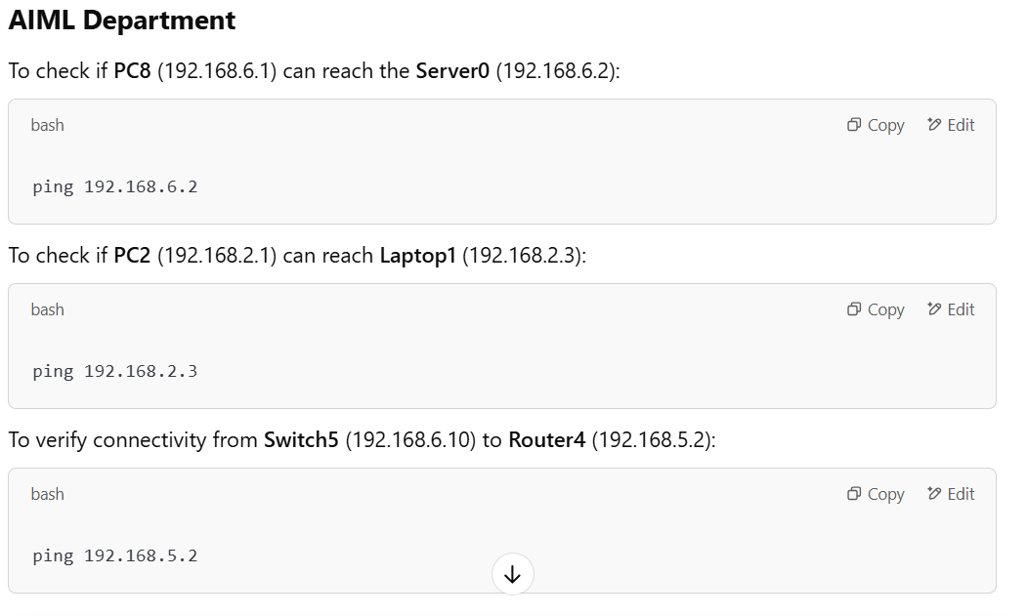

**2. Check Network Configuration (Windows)**

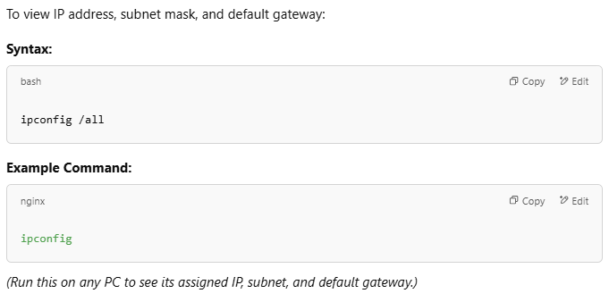

**3. Configure an IP Address on a Cisco Router**

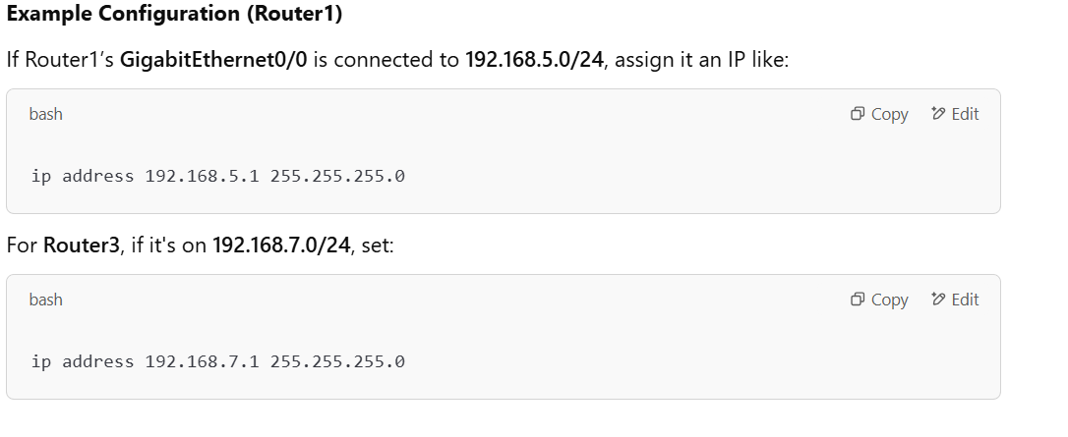

**4. Configure a Default Gateway on a Cisco Switch**

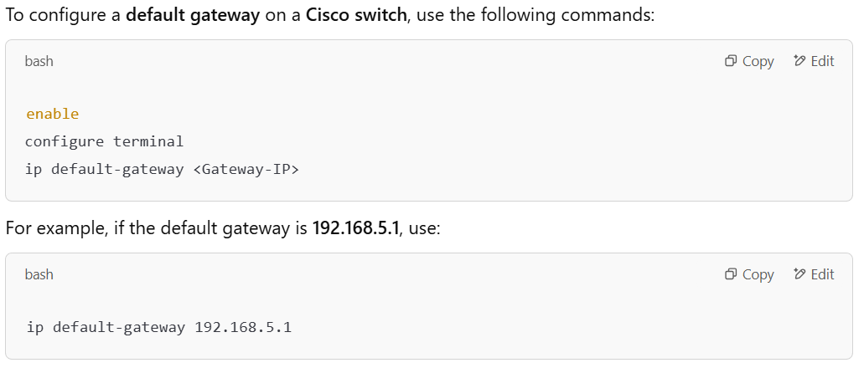

**5. Show IP Configuration on a Cisco Device**

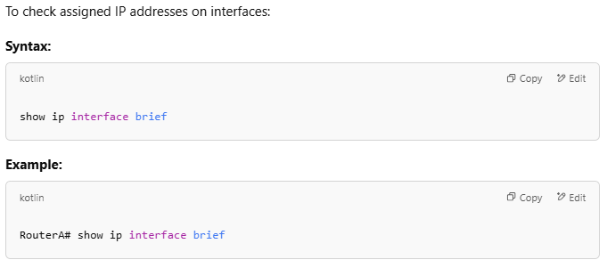

**6. View Routing Table (Windows/Linux)**

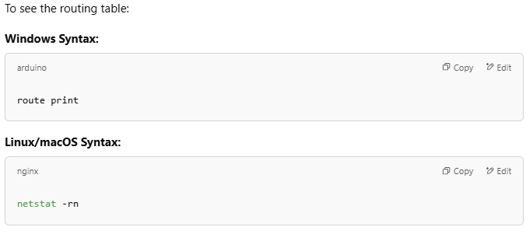

**7. Configure Static Routing (Cisco Router)**

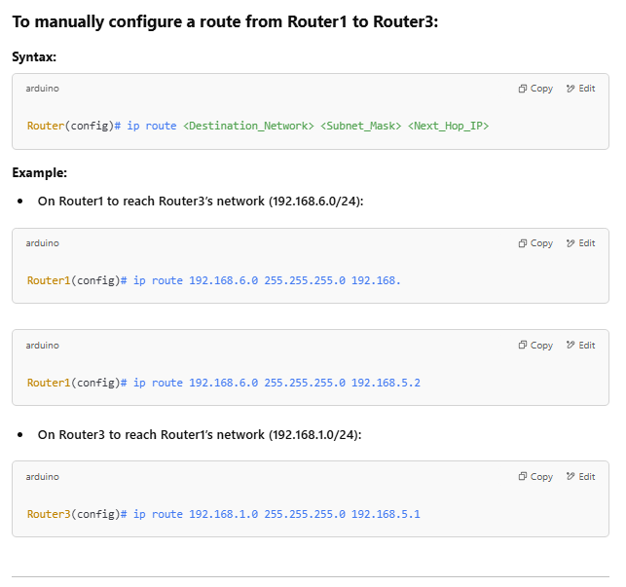

**5. Output:**

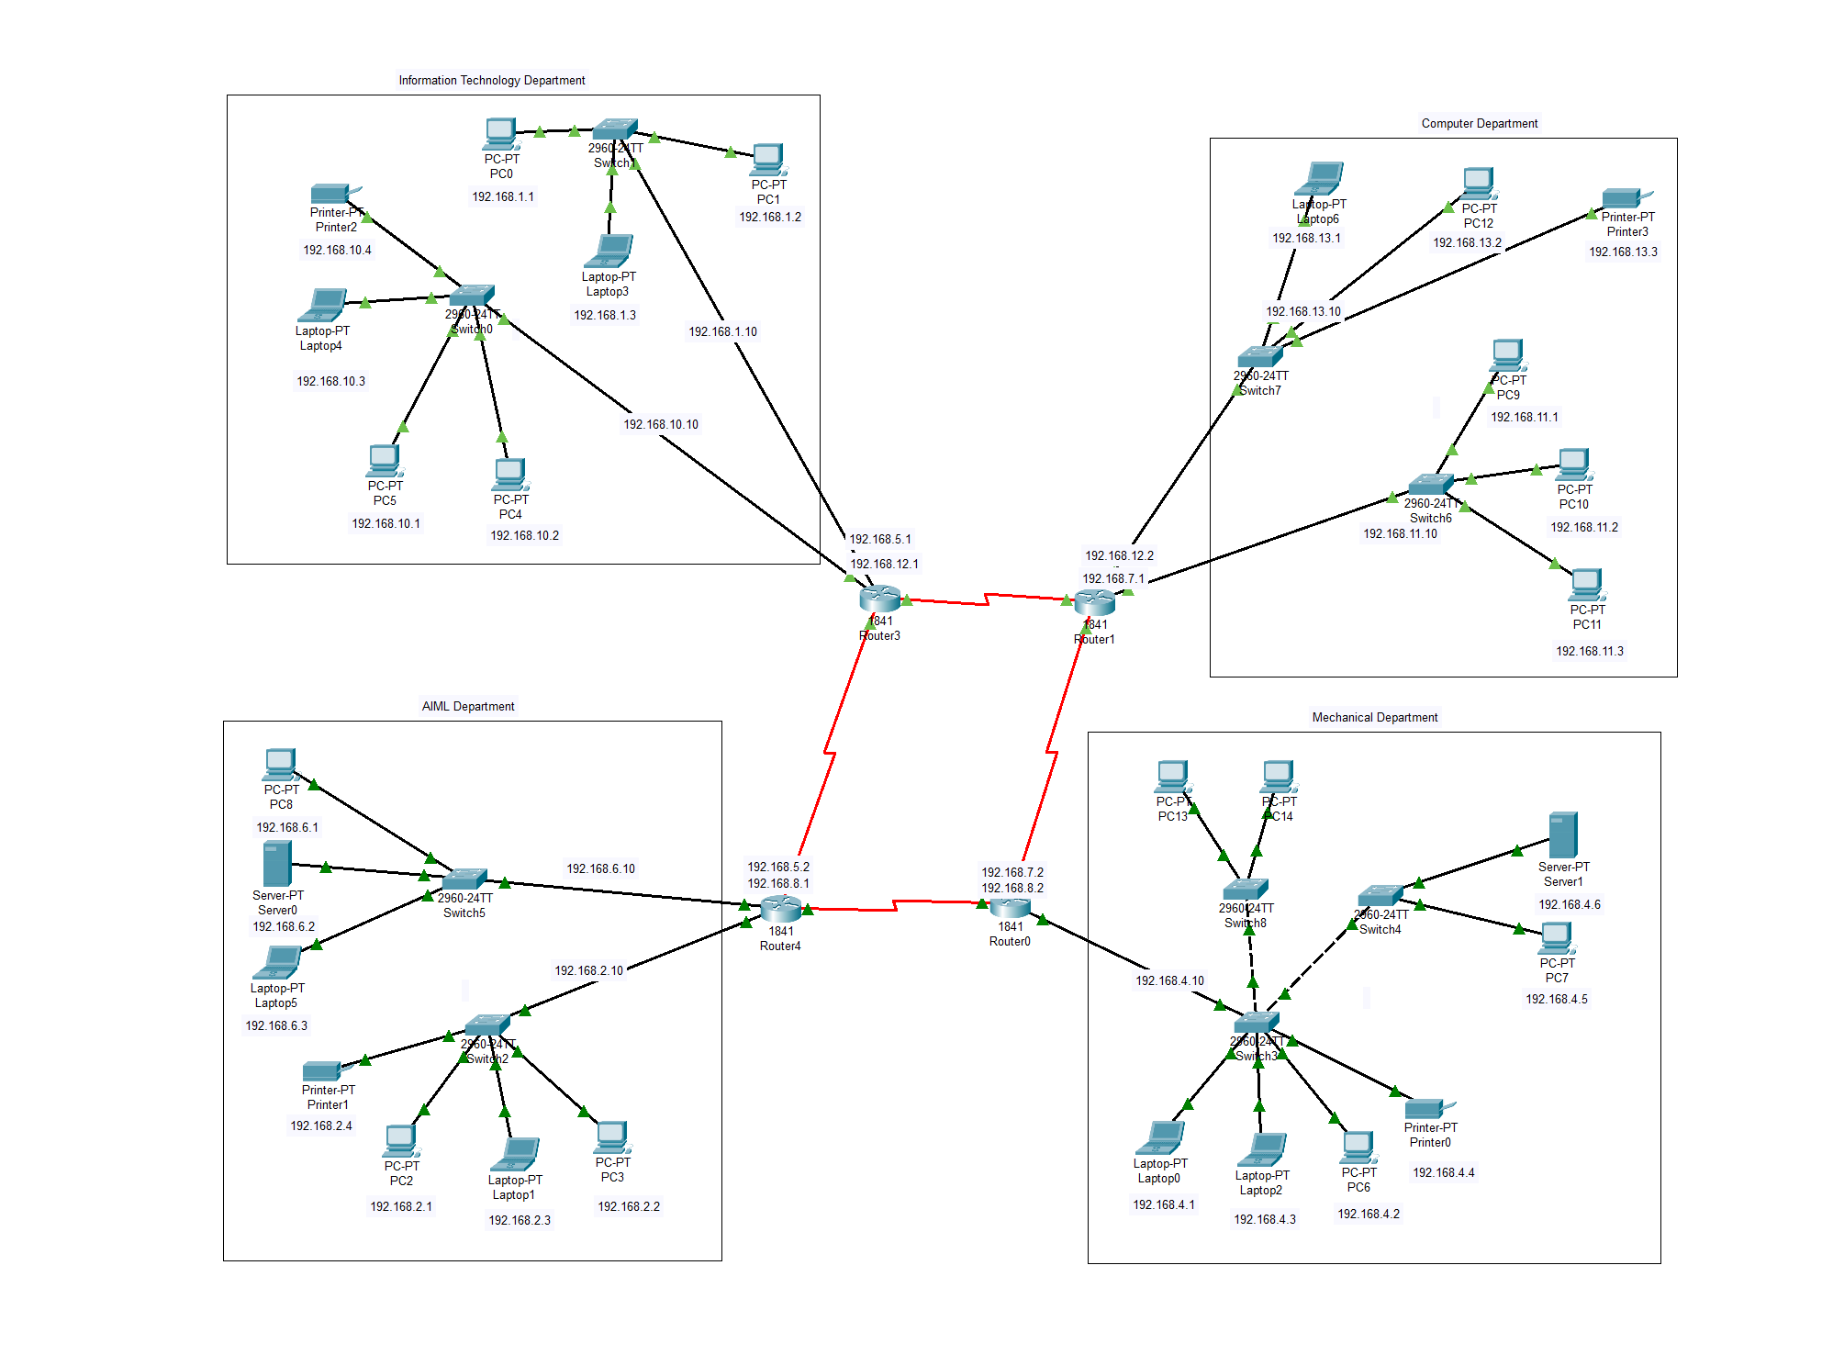

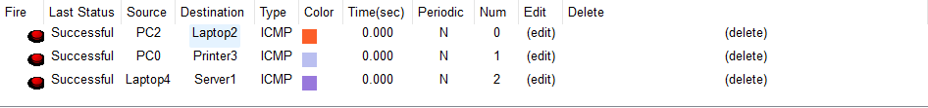

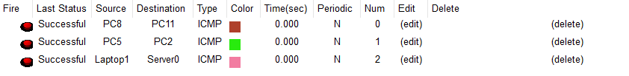

* A successfully configured network with proper IP addressing.
* Devices can communicate with each other through the router without issues.
* Verified data transfer between connected devices, ensuring a stable and functional LAN setup.

**6.Conclusion**

The wired LAN was successfully set up using a router. Manual IP configuration ensured that devices communicated efficiently within the network. Through this experiment, I gained hands-on experience in setting up a network, understanding routing concepts, and implementing static routing for seamless communication. This practical implementation enhanced our understanding of networking fundamentals and real-world network configurations.